Global Symposium on soil EROSION | FAO Hq | Rome, Italy, 15-17 May 2019

Policy framework on soil erosion and land degradation from the post conflict perspective of Bosnia and Herzegovina

Marijana Kapović Solomun^{1*}, Eleanor Campbell², Radislav Tošić³, Saša Eremija⁴

¹University of Banja Luka, Faculty of Forestry, Stepe Stepanovica 75A, 78000 Banja Luka, B&H
²University of New Hampshire, Earth Systems Research Center, Institute for the Study of Earth, Oceans, and Space. 366 Morse Hall, Durham, NH 03824 USA.
³University of Banja Luka, Faculty of Science, dr Mladena Stojanovića 2, 78000 Banja Luka, B&H.
⁴Institute of Forestry, Kneza Višeslava 3, 11030 Belgrade, Serbia.
[Corresponding author: marijana.kapovic-solomun@sf.unibl.org (*)]
Abstract: B&H is a post-conflict society and developing country facing serious challenges in sustainable land management, including poor socio-economic development and widespread perception of land as a less important resource. During the Land Degradation Neutrality Target Setting Process in B&H, land degradation status as well as drivers of land degradation were assessed in order establish the current state of land resources and plan for achieving the LDN target by 2030, in line with the LDN Global Agenda. Identifying and understanding land degradation drivers is critical for sustainable land use planning as well as the prevention of further soil degradation. Identifying the current state and pressures on land is a prerequisite for creating the necessary policy framework to achieve LDN from the local to the national level. However, the existence of a land-related policy framework may not be enough in a developing country where the supporting environment for implementation may be weak, and where the perception of decision makers varies. Some local government, for example, perceive some land degradation drivers e.g. floods, drought, landslides, as very important because these drivers affect them directly. In contrast a driver like soil erosion, this is less directly visible, and might be perceived as a “scientific” problem. This paper is aimed to present a policy framework related to land degradation, and particularly soil erosion, to efficiently address main challenges from the post conflict perspective of Bosnia and Herzegovina.
Keywords: land degradation drivers, soil erosion, legislation, implementation.
Introduction, scope and main objectives
Land degradation (LD) and associated soil erosion is an important challenge in Bosnia and Herzegovina (BiH) due to unsustainable land management ongoing for the last 25 years. BiH is a sovereign state with parliamentary state regulation and a decentralized political and administrative structure. Land and land resources are under exclusive jurisdiction of two entities (the Republic of Srpska Entity and Federation of Bosnia and Herzegovina Entity); therefore, land is regulated by the Entity-level rather than State-level legislation. The only land-related strategic document at the state level is the Action Program (AP) to Combat Land Degradation and Mitigate the Effects of Drought in Bosnia and Herzegovina (UNEP, 2017), while the main strategic documents are adopted and implemented on entity level. Since 2016, the Land Degradation Neutrality (LDN) Target Setting Process has been started in B&H (separately by entities), whereby main LD drivers are identified together with assessment of land resources, and wherein targets and associate measures are planned separately by each entity (Kapović Solomun, 2018; Čustović and Ljuša, 2018). Moreover, land monitoring systems have not been developed, so there are no exact data, complicating any estimation related to conditions of land resources in BiH, including soil erosion. Furthermore, the implementation of the existing policy framework is challenging under such a complex political and administrative structure. Policy and legal frameworks often mainstream sustainable land management (SLM) practices, but significant barriers exist for their effective implementation (Kapović Solomun et al., 2018).
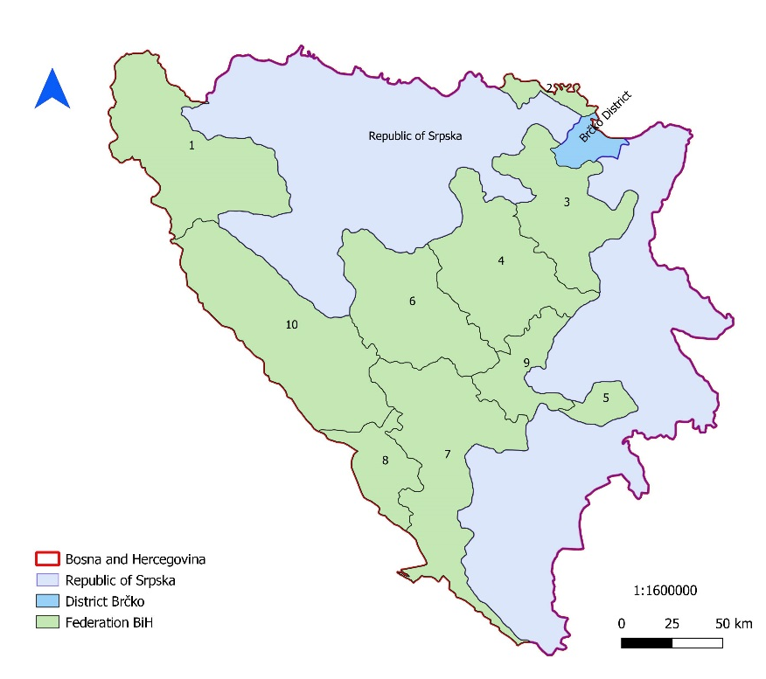
Fig. 1: [Administrative structure of BiH]

This paper is aimed to present a policy framework related to land degradation, particularly soil erosion, to efficiently address main challenges from the post conflict perspective of Bosnia and Herzegovina.
Methodology
Methodology is based on comprehensive review of existing national, entity and local policy frameworks in line with international commitments of Bosnia and Herzegovina in addressing land degradation (including soil erosion).

Results
BiH ratified the United Nations Convention to Combat Desertification (UNCCD) in 2002, recognizing the importance of land degradation and committing to Convention implementation, together with some EU Directives based on global policy documents. However, in reality addressing land degradation is very complex in BiH. This includes the decentralization and jurisdiction over lands that are reliant on Entity levels, together with complex political communication among institutions that together present great challenges for SLM. The existence of a defined policy framework sometimes is not sufficient to address environmental problem on the ground, including land degradation (Marković and Brujić, 2017). Furthermore, knowledge and awareness of decision makers about land is variable and often insufficient, and general public perception about land is not favorable. LDN processes in BiH revealed several land degradation drivers including: population migration and land abandonment, weak implementation of policy frameworks to protect the land; soil erosion, floods and drought; illegal felling that is conducive to erosion and landslides; industrialization and expansion of the area under exploitation of minerals as well as the landfills of mining waste; inadequate agricultural systems. Unfortunately, significant amounts data (e.g. Map on Soil Erosion of BiH) were destroyed during the Bosnian War (Witmer and O’Loughlin, 2009). Today BiH lacks reliable data and is behind on soil/land related research from the last century. The latest research on soil erosion in BiH dates from 1985, when a Map of Soil Erosion of BiH was developed by Lazarević (1985). Unfortunately that map has not been updated and moreover, data disappeared during the conflict period in Bosnia (Tošić, 2007). Since 2004 part of soil of the erosion map was reconstructed, but only for the Republic of Srpska territory (Tošić and Hrkalović, 2009; Tošić et al., 2012).
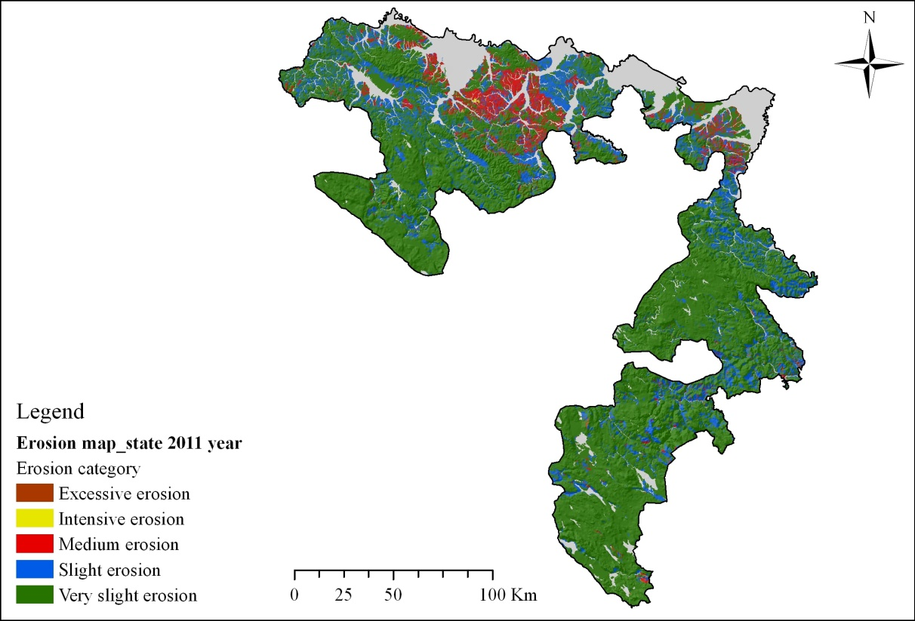
Fig. 2: [Erosion Map state in 2011 in the Republic of Srpska(Tošić et al., 2013]

Existing legislative framework on the Entity and local levels does not recognize soil erosion explicitly and there is no law on soil erosion. Main laws on the Entity level that indirectly address soil erosion are: Law on Water (Official Gazette of Republic of Srpska no. 7/06, 20/07, 86/07, 71/09), Law on Agriculture of the RS (Official Gazette of Republic of Srpska no. 7/06, 20/07, 86/07, 71/09), Law on Agricultural Land of the FBiH (Official Gazette of FBiH, no. 52/09), Law on Agricultural Land of the RS (Official Gazette of FBiH, no. 93/06, 86/07, 14/10, 5/12), and Law on Forestry of the Republic of Srpska (Official Gazette of Republic of Srpska no. 75/08, 60/13), Law on Spatial planning and Construction of the Republic of Srpska (Official Gazette of Republic of Srpska no. 55/10), Law on Spatial Planning and Land Use of FBiH (Official Gazette FBiH, no. 2/06) and Law on Environmental Protection of the Republic of Srpska (Official Gazette of Republic of Srpska no. 71/12) etc. In regards to the local policy framework and land use planning, legislation prescribes obligations for local governments to create local strategies on Land use planning. In the Republic of Srpska Entity, the majority of local communities did not create and adopt this strategy, due to the weak economic situation. However, after the LDN process where the Government took strong leadership, numerous local communities started with development of this important strategic document.
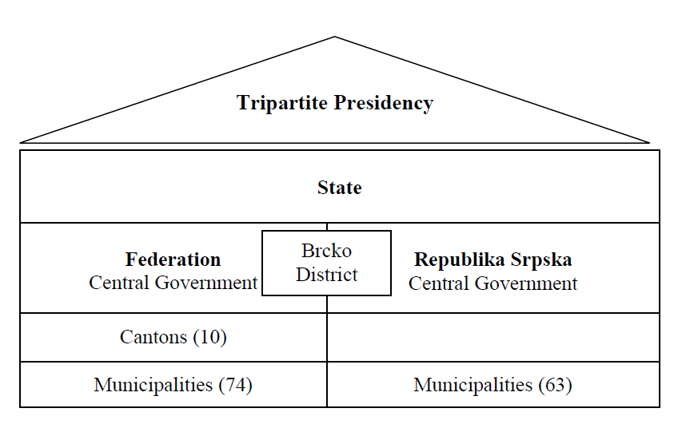
Fig. 1: [Constitutional framework of Bosnia and Herzegovina]
The Ministry of Agriculture, Forestry and Water Management of the RS (MAFWMRS) and the Ministry of Agriculture, Forestry and Water Management of the FBiH are the main institutions on the Entity level responsible for land and soil erosion. There are also other Ministries with jurisdiction related to land. Protection from soil erosion is important segment of water legislative framework, for example. MAFWMRS monitors and implement activities related to the development of documentation to determine erosion areas, erosion types, intensity etc. in accordance with Law on water, including prohibitions in the erosive areas. In FBiH, the implementation of strategic documents and legal acts is aggravated by the fact that the Federation of BiH has ten cantons that each have their own competences for land management, environmental and spatial planning. The cooperation of relevant ministries is not at a satisfactory level, as the strategies of various sectors are not harmonized. This creates additional pressure on land as well as conflicts (Čustović and Ljuša,, 2018). The strategic framework follows existing policies, but national allocations for implementation of prescribed action plan are very limited, and many activities rely on international resources.

Discussion
Considering the complex political and administrative structure of BiH, where land-related competences are at the entity level, the appropriate implementation of the existing legal and strategic framework and their synchronization and mutual co-ordination is of great importance to combat land degradation. As a post-conflict society with a weak socio-economic situation, BiH is often faced with the misunderstanding of the importance of land conservation, not only by decision makers but also by the population itself. Also, Civil War contributed to the destruction of valuable data, which implies the need for further research to update what has been done in the past Century. Land related issues most often rely on the academic community and non-governmental organizations, particularly in regards to understanding the consequences of soil erosion and soil degradation. Existing strategic and legislative frameworks have many disadvantages, but even as such (if implemented appropriately) land degradation issues would be addressed more effectively. However, the implementation of the legal framework is not effective, and the system of control often fails. The lack of data on land erosion as well as land monitoring makes it difficult to assess real land condition and to define priorities. Also, the existing land use planning system differs between entities and cantons in FBiH. Thus, the complexity of the legislative and strategic framework also creates complexity in approaches and implementations. In an environment with rising corruption, this presents a significant challenge to reduce, restore and reverse land degradation, starting from the local to the entity level and state level. This research has shown that political and administrative organizations have a significant influence on the implementation of land-related legal and strategic frameworks. In addition, the socio-economic impact of land perception is of great importance.

Conclusions
- The existence of a policy framework is important, but not sufficient if implementation is weak;
- Complex political and administrative structures complicate implementation of SLM, including soil erosion;
- Land degradation starts on the local level, so local decision makers play an important role in soil protection, particularly from a land use planning perspective;
- Stronger cooperation between science and policy is needed to improve land data exchange and the usage of scientific knowledge to address land degradation, such as soil erosion, through the introduction of new SLM;
- Development of a new, updated Soil Erosion Map of BiH is key to identify current soil erosion intensity and serve as a strategic document for development of Cadastre of torrents and torrent watersheds;
- Raising awareness and knowledge is generally important, especially at the local level. Existing agriculture advisory services under Governments should include more extensive education about soil erosion.

Acknowledgements
The views expressed in this information product are those of the author(s) and do not necessarily reflect the views or policies of FAO
References
Kapović Solomun, M., Barger, N., Keesstra, S., Cerda, A., Marković, M. 2018. Assessing land condition as a first step to achieving Land Degradation Neutrality: A case study of the Republic of Srpska, Environmental Science and Policy 90 (2018), 19-27.
Kapović Solomun, M. 2018. Program dostizanja neutralnosti degradacije zemljišta u
Republici Srpskoj, Banja Luka (Final report on Land Degradation Neutrality Target Setting Program in the Republic of Srpska, Banja Luka). . http://www.vladars.net/srSP-Cyrl/Vlada/Ministarstva/mps/Documents/LDN%20TSP%20Report%20za
%20Republiku%20Srpsku_470474363.pdf.
Lazarević, 1985. Soil Erosion Map of the Bosnia and Herzegovina, Sarajevo.
Law on Agriculture of the Republic of Srpska (Official Gazette of Republic of Srpska no. 7/06, 20/07, 86/07, 71/09).
Law on Agricultural land of the FBiH (Official Gazette of FBiH, no. 52/09).
Law on Agricultural Land of the Republic of Srpska (Official Gazette of FBiH, no. 93/06, 86/07, 14/10, 5/12).
Law on Environmental Protection of the Republic of Srpska (Official Gazette of Republic of Srpska no. 71/12) etc.
Law on Forestry of the Republic of Srpska (Official Gazette of Republic of Srpska no. 75/08, 60/13).
Law on Spatial planning and Construction of the Republic of Srpska (Official Gazette of Republic of Srpska no. 55/10),
Law on Spatial Planning and Land Use of FBiH (Official Gazette FBiH, no. 2/06)
Law on Water (Official Gazette of Republic of Srpska no. 7/06, 20/07, 86/07, 71/09),
Marković, M., Brujić, J. 2017. Overview of the natural resource management in Bosnia and
Herzegovina. In: Dragovic, N., Ristic, R., Pülzl, H., Wolfslehner, B. (Eds.), Natural
Resource Management in Southeast Europe: Forest, Soil and Water. Deutsche
Gesellschaft für Internationale Zusammenarbeit (GIZ) GmbH, Skopje, pp. 87–130
ISBN: 978-608-4536-07, Chapter 2.
Tošić, R. 2007. Problem erozije i upravljanje nanosom u Republici Srpskoj, Zbornik radova sa naučnog skupa “Srbija i Republika Srpska u regionalnim i globalnim procesima”, Beograd - Banja Luka.
Tošić, R., Dragićević, S., Lovrić, N. 2012. Assessment of soil erosion and sediment yield changes using erosion potential method - Case study: Republic of Srpska – BiH. Carpathian Journal of Earth and Environmental Sciences, 7 (4), 147-154
Tošić, R., Hrkalović, D. 2009. Inovacija karte erozije Republike Srpske, Voda i mi, Časopis agencije za vodno područje rijeke Save Sarajevo, Vo. 65, pp.54-66. Sarajevo.
Tošić, R., Kapović, M., Dragićević, S., Lovrić, N. 2013. Assessment of soil erosion potential using RUSLE and GIS: A case study of Bosnia and Herzegovina. Fresenius Environmental Bulletin, 22 (11a), 3415-3423.
Šarić, T., Sijahović, E. 2015. Održivo korištenje zemljišta na nagibima kao način
smanjenja poplava i šteta od njih u poljoprivredi. Simpozijum “Upravljanje rizicima od poplava i ublažavanje njihovih štetnih posljedica”, Sarajevo.
United Nations Environmental Programme (UNEP), 2017. Action Program for Combat Land Degradation and Mitigate the Effects of Drought in Bosnia and Herzegovina. UNEP, Sarajevo, Bosnia and Herzegovina. http://www.unep.ba/tl_files/unep_ba/PDFs/BHAP_eng_FINAL.pdf.
Čustović, H., Ljuša, M., 2018. Finalni izvještaj o programu dostizanja neutralnosti degradacije zemljišta u Federaciji Bosne i Hercegovine, Sarajevo (Final report on Land Degradation Neutrality Target Setting Program in the Federation of Bosnia and Herzegovina, Sarajevo).

